**Project Title:** Real time river water quality monitoring and control system **Project Design Phase-I** - **Solution Fit Team ID:** PNT2022TMID31045

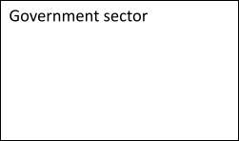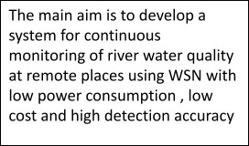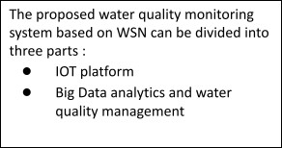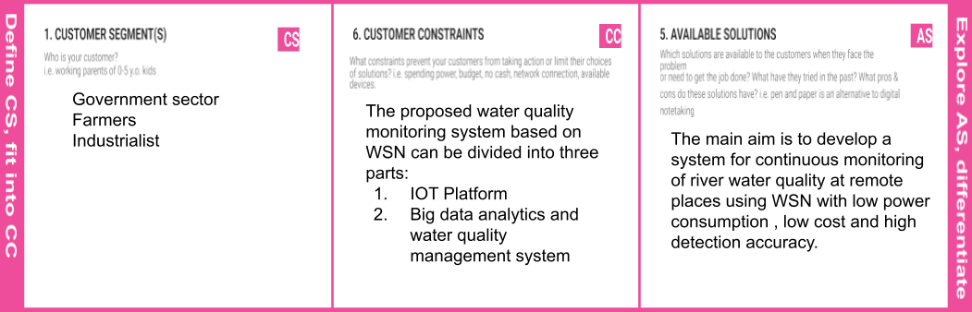

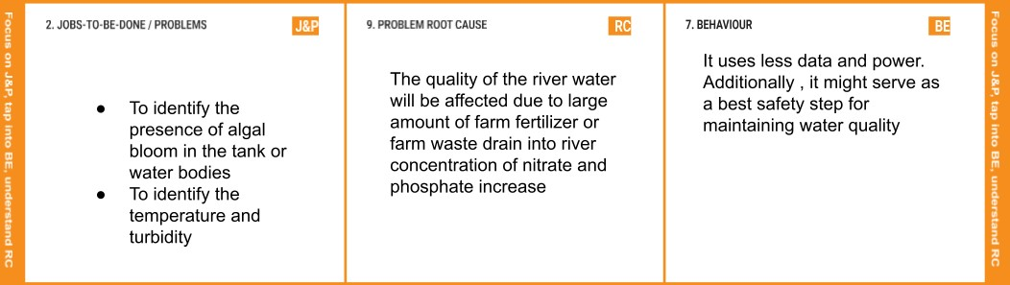

|  |  |  |  |  |  |  |
| --- | --- | --- | --- | --- | --- | --- |
|  | **3. TRIGGERS**   * It is small in size, so customer find it easy * They are able to recognize the issues with water without anyone. | **TR** | **10. YOUR SOLUTION**  Creating a MPC BUOY app to prevent algal  bloom using ultrasound as a control  measure | **SL** | **8.CHANNELS of BEHAVIOR CH**  **ONLINE**   * The cloud storage can be used to regulate the   waterflow   * Used to search websites , send the mail to authorities.   **OFFLINE**  The proposed system includes a number of sensors to test and guarantee the water quality based on factors including pH, temperature and turbidity |  |
| **4. EMOTIONS: BEFORE / AFTER EM**  Before:  Trouble in identify the turbidity and  temperature of river water  Rural people affected by the unpurified water After:  Using real time monitoring, instant data allows precursors to potential issues ( corrosion) to be flagged up and immediately be addressed before the major issue  The ability to make real-time decisions during critical moments can be important in preventing expensive repairs and breakdown. | |

